Project Narrative
For Postdoctoral Grant applications, the Project Narrative section may not exceed a total of ten-pages, 12-point font and line spacing not exceeding six lines per vertical inch including all figures and tables.

Training/Career Development Plan
plan must include plans for transition to career independence by development of professional skills. These professional skills include teaching competencies; what those career and training goals are; and results of the postdoctoral fellow’s previous and current research and scholarships that include publications, presentations, etc

Mentoring Plan
The applicants are expected to identify a Primary mentor who will be willing to help them in their application and projects as well as professional development (more than one Primary Mentor is acceptable for Integrated Projects Only). If there are other collaborating mentors, their role and responsibilities to the project and development of the applicant’s skills should be clearly described.

1)Briefly indicate how the mentoring and educational training will add to the skill sets of the NIFA Fellow.

Tim James and colleagues have explored some the fine scale spatial patterns in dispersal and population structuring in of one of the focal species of fungi for this proposal, Lecanicillium lecanii (Jackson, Zemenick, Malloure, Quandt, & James, 2016). The James lab and collaborators have also assembled the draft genome for L. lecanii (NCBI project accession PRJNA311919). The James lab has also investigated some of the microbial interactions of the coffee leaf rust (Hemiliea vastatrix)(James, Marino, Perfecto, & Vandermeer, 2016). In the process they have developed primers and PCR protocols for detecting the presence of the rust, which will be extremely helpful to execution of the proposed project. The James Lab, therefore, is a logical choice as a mentor in learning more of the skills and tools that will be needed specifically required for the biological system of interest.

Taking a broader perspective, however, microbial and fungal ecology is a hybrid discipline, requiring competency by a would-be microbial ecologist of a large and varied, “jack-of-all-trades” skill set that includes field, lab, theoretical, computational, and written skills. Similar to a general contractor in building construction, a microbial ecologist must have some mastery over these varied skills required to execute a project. This wider skill set gives the microbial ecologist the ability to gauge when to consult and collaborate, or when to take on tasks personally, given the limited time and resources of any microbial ecology project. Tim James represents an excellent mentor in this respect - he has broad, highly-collaborative research history that has touched most aspects of mycology, from deep phylogenetic work(Berbee, James, & Strullu-Derrien, 2017; Spatafora et al., 2016), to genomic analysis (Fernandez-Fueyo et al., 2012), to environmental meta-barcode surveys of fungi (James et al., 2016; Lazarus & James, 2015; Tedersoo, Bahram, Puusepp, Nilsson, & James, 2017).

2)Briefly explain the commitment of the primary mentor.
Tim James commitment in this project will consist of generally mentoring the molecular methods of the study. Additionally, Tim James will provide mentorship in genomic methods as we query the available genomic resources of H. vastatrix, Coffea, and L. lecanii (Cristancho et al., 2014; Denoeud et al., 2014; Talhinhas et al., 2014) with transcripts from the entire Coffea metatranscriptome (see project approach, below).

3)Briefly describe the role of collaborating mentors (if applicable).
John Vandermeer is a pioneer in the science of agroecology, and two of the three proposed sites were established as places of research by Ivette Perfecto and John Vendermeer. He will provide guidance on the field components of the project, help with interactions with coffee growers at and around the field sites in Puerto Rico and Mexico, and provide a classical ecological perspective on the microbial dynamics being surveyed.

4) With respect to the Primary Mentor, provide a list of former mentees and their current positions.
Graduate:
Thomas S. Jenkinson, Ph.D. (2017), currently a postdoc at UC Berkeley

Postdoctoral:
William J. Davis (2016-2018), currently at USDA Beltsville
Catherine A. Quandt (2014-2017), currently faculty at UC Boulder
John A. Marino (2014), currently faculty at Bradley University
Sujal Phadke (2013-2015), currently staff scientist at J Craig Venter Institute
Linda T. A. van Diepen (2009-2010), currently faculty at U. Wyoming

5)Briefly list and explain the role of other non-primary mentors.

Sania Miroslava Ortega will be a collaborator in the Ecuadorian site, where she will provide knowledge of Andean coffee pest management and modeling of fungal plant pathogens.

Project Plan

Introduction
Coffee is among the most traded agricultural commodities in the world: in 2018 an estimated ten billion kilograms of coffee were produced ( www.ico.org/prices/po-production.pdf ), and a nearly equal amount consumed (http://www.ico.org/prices/new-consumption-table.pdf ). Its agricultural production is an integral component of the livelihoods of millions of coffee growers and associated workers and their families (www.ico.org/documents/cy2016-17/icc-120-11e-five-year-action-plan.pdf
).

The largest threat to the economy of coffee is the fungal disease known as the coffee leaf rust (Hemileia vastatrix) (Talhinhas et al., 2017). This disease attacks the leaves of coffee trees, causing lesions at infection sites and eventually extensive leaf loss. Leaf loss eventually results in dead or debilitated trees that offer drastically reduced yields. The first instances of uncontrolled coffee rust disease were observed in Latin America in 1970 (McCook, 2006), but the disease did not cause catastrophic damage until several decades later, in a series of epidemics in the years 2008-2013 throughout Central and South America (Jacques Avelino et al., 2015). These epidemics resulted in millions in dollars of losses in populations of workers and growers already living in precarious conditions (McCook & Vandermeer, 2015).

The causes for the disastrous outbreaks were complex: social, economic, ecological, and climate conditions are all thought to have played a part (J. Avelino et al., 2006; Jacques Avelino et al., 2015; McCook & Vandermeer, 2015; Vandermeer, Jackson, & Perfecto, 2014). Accordingly, there is no single, simple remedy known for controlling outbreaks of the coffee rust, and there is no guarantee that the outbreaks of the first part of this decade were isolated or unusual events. Indeed, climate change is expected to exacerbate some of the conditions that promote the coffee rust (Jacques Avelino et al., 2015; Davis, Gole, Baena, & Moat, 2012). Economic conditions that have helped to give rise to the epidemic have not changed appreciably in the last several years (www.ico.org/documents/cy2016-17/icc-120-11e-five-year-action-plan.pdf). Thus there is reason to believe that more epidemics of the coffee rust in the western hemisphere may occur.

Even after being first observed, the disease did not emerge as a major pathogen in the Americas, and was even thought to be under control (McCook & Vandermeer, 2015). This is in contrast to nearly every other coffee growing region of the world outside of eastern Africa. In these other regions, when regions of arabica production were exposed to the coffee rust, the rust typically rapidly laid waste to Arabica coffee plantations. Traditional understanding is that strict quarantine procedures kept the Americas free from coffee rust until the first infected coffee trees were reported in Brazil in 1970 (McCook, 2006). The coffee rust did finally and suddenly surge to epidemic levels, after a 20-30 year delay from first observation of the rust. This can be compared to other regions such as Sri Lanka, the Philippines, and elsewhere where the rust rose from obscurity to epidemic in just years after first observations (McCook, 2006). Why did the coffee rust delay so long in reaching epidemic levels in Latin America long after the disease so quickly devastated other regions of the world?

Traditionally, the answer given to this question is that a combination of efforts by growers to control the rust with chemical fungicides, quarantines, and resistant varieties of coffee, in combination with lucky climatic conditions and topography slowed the rust until now (J. Avelino et al., 2006; McCook & Vandermeer, 2015). We argue that this answer leaves out the role of forests in the controlling the rust and that massive forest fragmentation and deforestation may be contributing to the epidemics of coffee rust recently experienced in Latin America.

Rationale and Significance

Research such as the extensive body of research by Vandermeer, James, and Perfecto and colleagues have shown that the most infamous antagonist to the coffee rust, the white halo fungus (Lecanicillium lecanii), is highly dependent upon a complex web of ecological interactions (James et al., 2016; Vandermeer, Hajian-Forooshani, & Perfecto, 2018; Vandermeer et al., 2014; Vandermeer, Perfecto, & Philpott, 2010). This complexity is probably not unique - the possibility exists that all microbial antagonists to the coffee leaf rust may require complex ecological interactions that only complex habitats such as forests can provide.

Biocontrol as an ecosystem service by forests to nearby agriculture may offer another explanation for the long delay of coffee rust epidemics in the Americas. Antagonism to the coffee rust by L. lecanii numerous and other microbes may have been at work, as most areas where coffee is grown in the Americas are also historically forested. As deforestation accelerated (Fearnside, 2005; González-Jaramillo et al., 2016; Rosa, Smith, Wearn, Purves, & Ewers, 2016) in the mid-20th century, and forests edges retreated farther and farther from areas of coffee cultivation, beneficial microbes that required the forest habitat may have become increasingly rare. Organisms such as the white halo fungus may not have been able to sustain population levels sufficient to act as biocontrols against the rust in the increasingly vast and increasingly simplified landscape.

Given this, and the numerous historical problems in implementing biocontrol microbes (Andrews, 1990; Orozco-Mosqueda, Rocha-Granados, Glick, & Santoyo, 2018), we argue that perhaps fungal biocontrol species such as the white halo fungus are most likely to succeed as part of a continual exposure by crops to a diversity of fungi and numerous other organisms. This level of exposure and biodiversity may only be economically possible for farmers when wild ecosystems such as forests are present nearby and are able to export these microbes as an ecosystem service. This proximity to forests may be necessary because most farms are simplified ecosystems, especially “technified” farms, and may not contain sufficient ecological complexity themselves to maintain conditions necessary for microbes of interest (Kremen & Miles, 2012). Thus, we hypothesize that forests may be necessary sources of unique and beneficial microbes to surrounding simplified ecosystems, such as farms.

Extensive indirect evidence exists for this hypothesis:

- The coffee rust is observed on wild arabica and other members of the coffee family in forest settings (McCook, 2006; Samnegård, Hambäck, Nemomissa, & Hylander, 2014), apparently in an equilibrium with its prey. Coexistence of coffee and its pathogens is possible, in the right ecological setting (forests).

- Many microbial antagonists to coffee rust are thought to exist in the wild (Haddad, Maffia, Mizubuti, & Teixeira, 2009; Haddad, Saraiva, Mizubuti, Romeiro, & Maffia, 2014; Silva, Tozzi, Terrasan, & Bettiol, 2012; Vandermeer et al., 2018), especially in the forests of Ethiopa where coffee and the coffee leaf rust are thought to have coevolved extensively. However, none of the antagonists of the rust have yet successfully performed as biocontrols.

- Coffee tree germplasm from the forests in the native range of arabica and the rust do not show promise for finding further resistance genes (Talhinhas et al., 2017), despite the lower intensity of the rust in these areas. This may imply that other mechanisms beyond host resistance genes are at work in controlling the coffee rust.

- Incidence of the coffee leaf rust was found to be positively correlated with percent of nearby land in pasture in Costa Rica, as opposed to more complex land uses such as shade coffee, forest, or other agriculture (Jacques Avelino, Romero-Gurdián, Cruz-Cuellar, & Declerck, 2012).

- Sterile plants placed under forest canopy are apparently exposed to more fungal spores and were observed to establish their non-disease fungal microbiomes more quickly than those placed in clearings (Arnold & Herre, 2003).

- Old growth tropical forest at a site in Costa Rica harbored more fungal species of the family of the white halo fungus, Cordycipitaceae, and closely related Clavicipitaceae (Chaverri & Vilchez, 2006), than in nearby second growth forests. Similar trends were shown for another closely-related family with mycoparasitic species, Ophiocordycipitaceae (Gazis & Chaverri, 2015).

- Second-growth forest located beside primary forest showed higher fungal diversity than secondary forest located away from primary forest, in the same study (Chaverri & Vilchez, 2006). This suggests the “export of microbial diversity” hypothesized above is occurring and helps secondary forests to recover important microorganisms.

- Large, “mainland” forest patches in coastal California were observed act as sources of mycorrhizal fungal diversity to surrounding forest fragments, and that this ecosystem service decreased with distance (Peay, Garbelotto, & Bruns, 2010; Peay, Schubert, Nguyen, & Bruns, 2012).

- Rubber plants in amazon forest settings are associated with a higher diversity of protective, mutualistic fungi than rubber plants grown in nearby plantations (Gazis & Chaverri, 2015).

- In some areas of Puerto Rico, where the coffee rust appears to be heavily impeded by fungal antagonists, coffee growers inoculate coffee trees with slurries made from leaf litter from nearby forests (Vandermeer, pers. comm.).

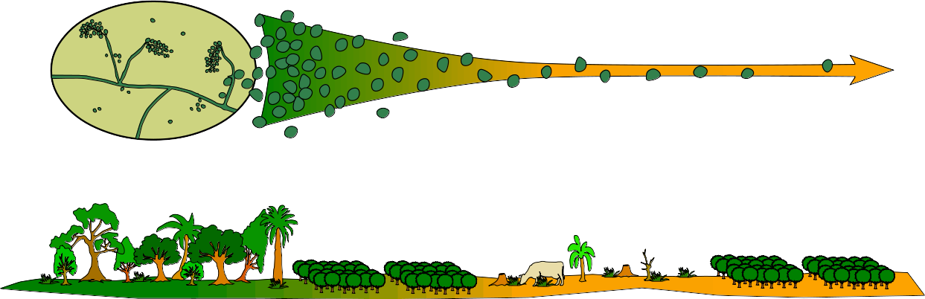
Figure 1. We hypothesize that forests may supply surrounding agricultural landscape with spores from mutualistic, protective fungi. This service may diminish with distance from the forest edge.

Approach

Hypotheses:
H1) Forest ecosystems provide biological complexity necessary for microbial biocontrols of the coffee leaf rust to thrive and keep coffee leaf rust populations from reaching epidemic levels.

H2) This biocontrol service diminishes with distance from forest edge due to dispersal limitation of fungal spores.

Predictions:
P1 - Coffee leaf rust disease severity will decrease with proximity to forest.

P2 - The fungal microbiome of coffee plants close to the forest edge will more closely resemble forest plants’ microbiomes than coffee plants located farther away from forests.

P3 - Incidence and symptoms of Lecanocillium and other potential rust antagonists will increase in frequency with proximity to forest, especially older and larger forest areas, in the air (spore traps) and microbiome of plants.

P4 - Parasitism of rust lesions by L. lecanii will decrease with distance from forest.

P5 - Rust spores in the air column will not vary with distance from forest.

P6 - Host (coffee) transcriptome will show increased rust-induced resistance-signaling responses at greater distances from forest edge, and the host mycobiome will show increased expression of genes relating to mycoparasitic activity closer to forest edges.

Methods:
In general, we propose a set of surveys, intended characterize landscape level patterns of the coffee fungal microbiome in coffee farms at forest edges. Particular attention will be given to the coffee leaf rust and the white halo fungus, but multiple methods are employed to characterize changes in the microbiome of coffee as a whole in relation to forest edges. This includes trial of a novel method for sampling changes in coffee leaf metatranscriptome.

Field methods

Protocols - We will sample three, approximately 1 km x 1 km areas (Figure 2). These areas will be selected on the basis of: (1) density of coffee farms, (2) landholder interest in this project, and (3) adjacency of plot to a large forest area on one side. Plots will be sampled according to a grid of points spaced every 100m. Approximately 25% of points will lie inside of forest edges. Candidate sampling sites will be first nominated using the Global Forest Change Database (Hansen et al., 2013), along with the knowledge of collaborators who are most familiar with each of the respective communities, followed by confirmation by site visit and discussion with landholders/growers at each site.

The mycobiome of the closest non-resistant coffee tree to each of the points will be examined. Two leaves from each tree will be collected for endophyte culture (see laboratory methods below). The same amount of each will also be collected for direct RNA and DNA sequencing. If the coffee rust is present on the plant, infection severity will be noted (J. Avelino et al., 2006), as well as proportion of rust lesions parasitized by L. lecanii.

For points lying inside of forests and forest fragments, the closest member of Rubiaceae to the grid point will be sampled in the same manner as cultivated coffee plants: the members of the genus Hemileia very often parasitize plants in Rubiaceae⁵⁶, and may have coevolved with these hosts. They may also therefore tend to harbor hyperparasites or other antagonists to Hemileia rusts.

In addition to mature coffee plants, seedlings of sufficient size will be sourced and used as “bait” plants. These seedlings will be placed regularly at a subset of sampling sites. Leaves from these seedlings with be removed, and bark will be sanitized. The second flush of leaves from these defoliated seedlings will occur in situ (forest) with a relatively reduced initial fungal diversity (Arnold & Herre, 2003) and will then accumulate species from the surroundings. These new leaves from seedlings will be sampled for endophytic fungi in the same manner as with leaves from mature trees, and allow comparisons of coffee plants within and outside forest setting that otherwise may not be possible.

To gauge spore dispersal, rainwater spore traps will be positioned in a subset of samples, in the form of funnels into sterilized 4-liter jugs with fungal growth inhibitors and DNase inhibitors (Peay et al., 2012). The water in these spore traps will collected, filtered to remove large debris, and centrifuged repeatedly to entrap spores as a pellet. Spores will then be preserved in DNA-stabilizing buffers and processed as with leaf tissue samples.

Both seedlings and spore trap protocols represent a significantly additional amount of labor. As large a subset of spore and seedling sample sites as can reasonably managed will be installed, but this number will depend on the level of interest by coffee-grower collaborators. As a first goal, we will attempt to sample 25% of all sample sites for spore deposition and with seedlings.

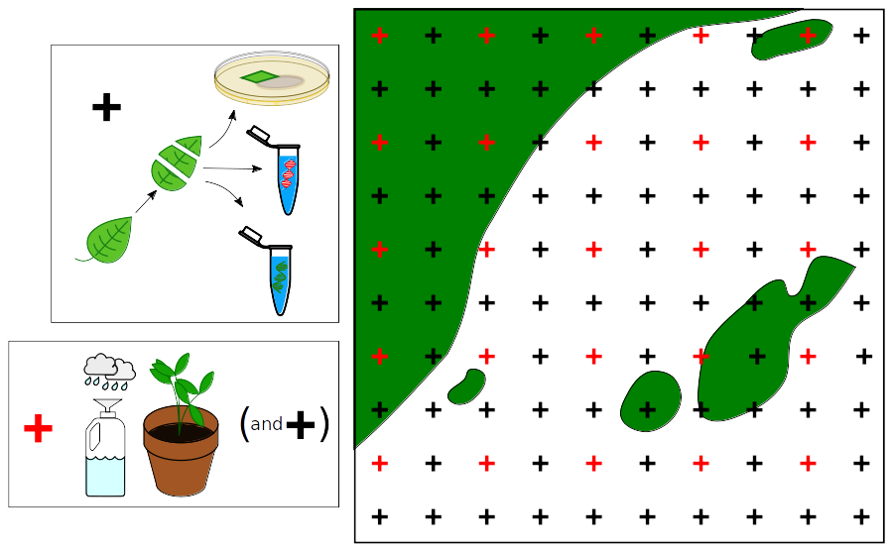
Figure 2. An idealized summary of field methods. At each of three plots per site, we will sample a 1 km² area, taking leaves from a coffee every 100 m. Leaf material will be used for culture libraries, DNA-barcoded libraries of fungal symbionts, and RNA for transcriptomic response by both coffee plants and their microbiome. At a subset of plots (red), spore traps and “bait” seedlings with new leaves will be placed.

Lab methods

Direct PCR and fungal community PCR – Leaf and spore-trap samples will be processed for DNA extraction and sequencing. ITS region illumina metabarcoding of leaves (Daniel Thomas, Vandegrift, Roy, Hsieh, & Ju, 2019), will provide an overall picture of fungal microbiomes. However, metabarcoding can be an inexact tool when searching for particular microbial species among the entire microbiome. As such L. lecanii and H. vastatrix species-specific primers in ITS region will be designed and used to specifically confirm the presence of these fungi in plants, even if symptoms are not otherwise present. Primers will be designed for the ITS region, using existing sequence data available in public databases. The James lab has already designed primers for direct PCR surveys for the presence of H. vastastrix.

Transcriptome/RNA – Some leaf tissue will be stabilized with RNAlater (Passow et al., 2018) or comparable product. If necessary, further field-stabilization methods may be employed, including light tissue homogenization (Kido, 2016), to allow for penetration of storage reagent past the cuticle. Material will be submitted for RNA extraction and sequencing at a genomics core facility. Refrigeration at appropriate temperatures for RNA shipment is probably not available from laboratories for our sites to genomics facilities, so shipping of samples will have to occur in RNAlater solution, or comparable product. For this reason, sample processing from sample to illumina-tagged library construction will be done by a genomic facility that offers RNA extraction and cDNA library construction services. We will conduct power analyses of the new method to estimate necessary sequencing depth and thus number of samples ultimately submitted for sequencing.

Culture library – Leaves will be processed for cultivation of endophytic fungi: leaves will be surface- sterilized, sectioned and plated on malt agar medium, following Thomas and Vandegrift et al. (D. C. Thomas, Vandegrift, Ludden, Carroll, & Roy, 2016). Sporulating fungi will be grouped into morphospecies, and given preliminary IDs by morphology. All sporulating fungi will be photo-documented at appropriate magnification. Any specimens of interest will be grown in liquid media for DNA purification and sequencing, and identified using full ITS sequences. This will allow Researcher collaborators at _____ (universities) will be sought to conduct this aspect of the project, after training in cultivation of fungi and extraction of DNA from fungal cultures.

Bioinformatics
Whole fungal community analysis – read preparation, OTU clustering, and taxonomy assignments of illumina ITS libraries will follow the usearch pipeline (Edgar, 2010), with precautions as noted in Thomas et al. (2017) and Edgar (2017, 2018).

Transcriptomic analysis – Differential expression in host plant (coffee) gene expression and enrichment of pathways will be examined for correlations with severity of infection by coffee leaf rust and change using standard RNAseq bioinformatic pipelines (Conesa & Götz, 2008; Conesa et al., 2016; Love, Huber, & Anders, 2014; Pertea, Kim, Pertea, Leek, & Salzberg, 2016; The Gene Ontology Consortium, 2019).

For analysis of coffee microbiome gene expression, we propose a novel method of “scavenging” the microbiome transcriptome from host RNAseq libraries. RNAseq studies of large organisms very often leave 15-20% of total reads unaligned to the genome of the targeted organism. These reads are typically discarded, as RNA expression in the large organism is usually the focus of RNAseq studies. These discarded reads can originate from sequencer error and laboratory contamination, but many also originate from the transcriptome of the microbiome.

Instead of traditional quantification of differential expression followed by pathways analysis, unaligned transcripts will be as closely categorized as possible using GO annotations from blast matches to fungal model organisms. This will result in a matrix with rows of plant samples by columns of gene functions, where cells are populated by fragment counts, which will be weighted by estimates of gene lengths and library sizes. See below for downstream statistical analysis.

Support for novel transcriptomic method:
In a test of concept for this method, we aligned 11 transcriptome samples from a publicly available transcriptome (Reichman et al., 2018) to the host (Pseudotsuga menziesii) genome (Neale et al., 2017). For each of these samples, approximately 15% of reads are unalignable to the host. We blasted the reads not aligned to host genome against a database of ~10,000 fungal genes randomly selected from NCBI genbank. The average proportion of total reads (including those aligned to host) with high confidence matches to fungal genes in this database was 0.4 %. This amounted to average of ~50,000 fungal reads per sample, with each sample containing an average of ~11,700,000 reads before alignment to host . If this rate applies to other sequencing events, in a single lane of illumina HiSeq 3000/4000 with 50bp per read, we may expect to see as many as 2,700,000 fungal reads. Some amount of these reads must be due to laboratory contamination, but presumably the majority represent coocurring fungi, as handling of samples for any other reason than RNA isolation is necessarily minimal, due to the hazards of rapid degradation of RNA.

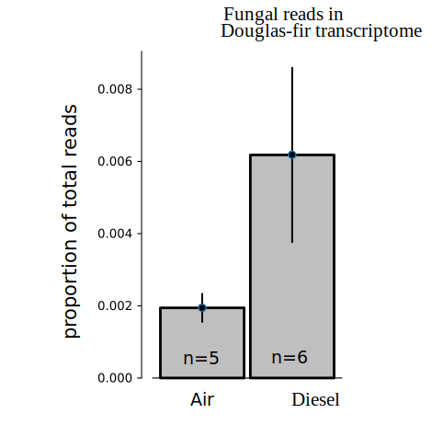
Figure 3. A first test of sampling the plant metatranscriptome. Fungal reads were found to constitute between 0.2 and 1% of a plant transcriptome, and abundance varied between the two treatments.

Statistical methods

Direct PCR results - Visually scored, incidence (presence/absence) data of the coffee rust and L. lecanii will be recorded and analyzed as point-pattern data (Baddeley, Rubak, & Turner, 2015), as will data from the detection of these two species by species-specific primers as described above. These spatial incidence data will be fitted to point pattern models, and tested for trends of decay with distance from forest edges. Confounding variables, including elevation, coffee variety and agricultural methods, will be included in models as covariates.

Whole fungal community analysis - Spatial analyses of entire fungal communities from illumina sequence data, rather than single species, will be examined with multivariate spatial statistical methods. Variation in our fungal community matrix will be analyzed with a comparison of redundancy analyses of spatial and environmental variables, also known as variation partitioning (Borcard, Legendre, & Drapeau, 1992; Legendre & Legendre, 2012). Comparisons of community composition of coffee tree microbiomes will also be made directly to samples of seedlings placed in forest settings. Candidates for antagonistic fungi in this data will be identified through coocurrence network analysis, and taxonomically (e.g. members of Cordycipitaceae and allies). These candidates will be searched for in the final ITS barcodes of culture libraries.

Metatranscriptomics - Matrices of gene expression for the microbiome from each plot as created above (see bioinformatics) will be considered sampling events of metatransciptomes from each host plant. After removal of host reads and categorization of reads into functional groups, we are likely to be presented with a situation often faced by ecologists – comparison of rows of a sparse matrix. Where data are too sparse for standard pathways enrichment tests, we will attempt to use distance-based ordinations compare visualize (dis)similarity of samples, from both a taxonomic and functional standpoint. PERMANOVA (Anderson, 2017) or other dissimilarity-based pseudo-linear models will be used to statistically test dissimilarity of samples as predicted by distance to forest or rust severity. Distance metrics will be further researched to find best practices for this application. Hypothesis testing is also possible, by testing groupings of genes into pathways of interest as explanatory factors in a PERMANOVA model.

Culture library: ____________

Evaluation Plan
We will use the following benchmarks for evaluating progress:

Fall, 2020:
- Select sample sites remotely and contact growers
- Visit 1 to sites:
- confirm interest and cooperation of growers/landowners for sample sites.
- Commit grower for arabica seedlings.

Winter 2020/2021:
- Develop and test species-specific primers for direct PCR assays for Lecanicillium lecanii.
- Begin trials and power analysis of metatranscriptome methods
- Visit 2 to sites
- Sanitize seedlings and place seedlings at sample locations.
- Identify and train undergraduate collaborators in preparation for creation and curation of culture libraries at each sample site.

Spring 2021:
- Visit 3:
- Undertake sampling at sites.
- Initiate culture libraries with in-country collaborators.
- Stabilize samples for RNAseq libraries and submit for sequencing.
- If export permits for tissue allow, return to Michigan with remaining leaf tissue, stabilized.
- Prepare multiplexed ITS-only illumina-tagged ITS libraries and submit for sequencing.
- Direct PCR screens for L. lecanii and H. vastatrix.

Summer 2021
- Begin ITS barcoding and archiving of culture library
- Begin analysis of ITS and RNAseq data and point patterns of L. lecanii and H. vastatrix.

Fall-Summer 2021
- Continue analysis
- Begin writing of manuscripts. We expect three manuscript products:
- Methods report on sampling host transcriptomes
- Ecological summary of patterns observed in (meta)transcriptomic, fungal community ITS, and direct PCR data.
- Final report on culture library, including possible candidates for antagonism to rust.

Lecanicillium lecanii is also known as is also known as Verticillium lecanii, Akanthomyces lecanii, and Cordyceps or Torrubiella confragosa (teleomorph) (Kepler et al., 2017; Sung et al., 2007) .

